How would you choose to be remembered? (433 words)
By Bob ‘Idea Man’ Hooey
The earlier part of 2005 saw the loss of some close Toastmaster friends, as well as my next door neighbor, who was only 2 years older than me. I spoke at Ron's service and reminded the family and friends of his many gifts, our great times of shared laughter and love.
Last week I attended a funeral of a 96 year old member of my extended family... my brother-in-law's aunt and grandmother to a close friend. Last year (2014) we lost both of my wife’s parents.
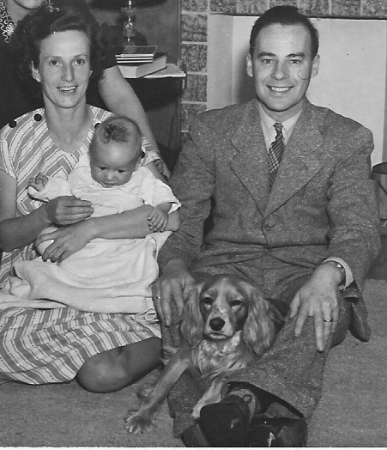
Makes you think! When you lose someone close to you, it challenges you, in a very deep way, to re-examine your own life and activities. I know in 1999, when both my parents passed away, I made some serious and substantial changes in my life, my business and how I invest my time.
"This is the true joy in life: Being used for a purpose recognized by yourself as a mighty one, being a force of nature instead of a feverish, selfish little clod of ailments and grievances, complaining that the world will not devote itself to making you happy. I am of the opinion that my life belongs to the whole community and as long as I live, it is my privilege to do for it what I can. It is a sort of splendid torch which I have got hold of for the moment, and I want to make it burn as brightly as possible before handling it on to future generations." George Bernard Shaw
I keep this quote on the wall in my bedroom, so it gets seen on a frequent basis. It serves as a visual reminder of my own desire to make sure I too, burn brightly and give solid value in everything I do.
Fellow author, speaker and former Edmontonian, Brian Tracy shared his wish to be remembered. His choice, "Brian Tracy had a profound and positive influence on improving the lives of millions of people." From what I gotten to know of Brian over the years, it appears he is well on his way to making this a reality.
My challenge for you is to revisit how you would choose to be remembered. I wish each of you a long and productive life. Productive is a subjective term - so however you define it - you can create it!
However, each of us has a specific time here on earth to accomplish what we may. We can choose to make a statement with our life and the legacy or legend that we create in living it. What is your choice?
© Copyright 2015 Bob ‘Idea Man’ Hooey www.ideaman.net www.BobHooey.training
All rights reserved. Used with permission of the author.

Bob ‘Idea Man’ Hooey is a creative, productivity and leadership strategist who regularly writes for North American Consumer and Trade Journals, on-line magazines and company intranets. He works with Canada’s 50 Best Managed Companies. He is the prolific author of multiple business and leadership books and the 48th person in the history of Toastmasters International to earn their coveted professional level Accredited Speaker designation.

Articles may be copied or used for non-profit purposes, without the consent of the author, subject to the following being included: © Copyright 2015 Bob ‘Idea Man’ Hooey www.ideaman.net www.BobHooey.training All rights Reserved. Used with permission of the author.

